|  |  |
| --- | --- |
| **Project – External Documentation** |  |
| COMP6583 | COMP6583001  Computer Graphics |
| Odd Semester Year 2023/2024 |

* Project Title

PLANTS NO ZOMBIES

* Introduction

Pop Corn, the game company that created the classic game Plants NO Zombies is planning on releasing its newest game release in 3D. We, as the idea designer, are asked to create a prototype scene based on the original game using three.js.

* Report / Documentation

For our project of Plants No Zombies, we used three.js to code the game, and we used Orbit Controls, Font Loader, Text Geometry, and GLTF Loader library to make the project a reality.

Firstly, we setup the scene, camera, and renderer

Since it is requested to have a different camera perspective when pressing a key between first person and third person perspective, we coded 2 different cameras and then create a camera switch to declare the active camera

After the creation of the world, we need to create the light for the world. We used 2 types of lights which are ambient light to create a baseline & depth of light, and then a spotlight to brighten the action. There is an added feature to change the setting into day and night in a push of a button too, so we also coded when the setting is night, we reduced the light generated.

After light, we need to create a surface for the objects to be placed on. There is a grass surface available, but for the code we need to implement a special rotation to make it horizontal.

Since the game is called Plants No Zombies, we need plants and zombies. For the zombies, we used a graphics library transmission format (gltf) to transform the zombie’s element like shapes and surfaces through a loader to create a zombie shape in a t-pose.

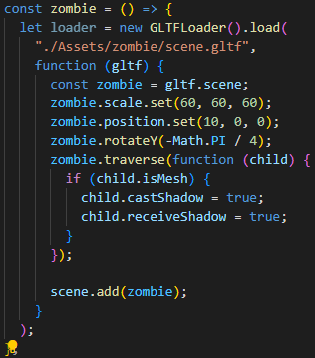

And then we add the text to display the name of the game

To add decorations to the area, we added some fencing to the grass. We also used GLTF to load the fencing element. Here is the sample code:

Then, we create a peashooter to shoot the zombies away. The way to interact with it is to click the peashooter’s head to shoot a projectile.

To add some protection to the peashooter, we add some walnut to protect it

And then we give it some sky to resemble some correlation with the real world. We just load some textures to the world cube. There are 2 modes to the skybox which is the day and night. And to change, we just change the loaded skybox.

And lastly, we load all of it to the window.

1. First Person Perspective based on the peashooter on day

1. First Person Perspective based on the peashooter on night

1. Third Person Perspective based on the peashooter on day

1. Third Person Perspective based on the peashooter on night

1. Third Person Perspective peashooter shooting pea to the zombie

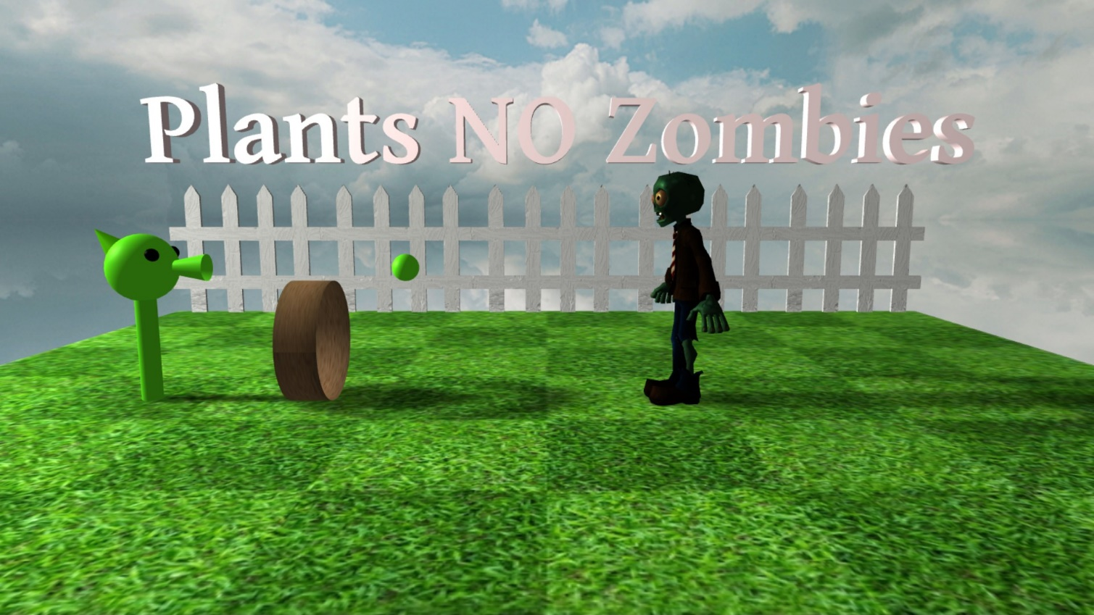

* Reference
* https://render.fineartamerica.com/images/rendered/default/poster/10/8/break/images/artworkimages/medium/2/popcorn-texture-marcus-jules.jpg
* https://thumbs.dreamstime.com/b/green-grass-field-background-soccer-football-sports-lawn-pattern-texture-close-up-image-142564163.jpg
* https://skfb.ly/6ZZNq
* https://skfb.ly/o7HxM
* https://opengameart.org/content/cloudy-skyboxes
* https://opengameart.org/content/night-sky-stars-and-galaxies
* Group Member
* 2501975116 – ERYN ANGELA
* 2502073794 – NUKY YASUAR ZAMZAMY
* 2540126033 – YOHANES ANDREW WIJAYA